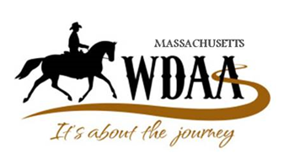 WDAMA Online WD MayaBloom
WDAA Recognized Show – 21-207
Video Submission: April 10 – April 29
Class Number:
Level & Test:
Rider:
Horse:

